**Bachelor thesis**

**Topic:**

**Development of a database system and a WEB application for product sales**

Student: **Anton Ivanov Ivanov**

Matriculation Number: **201218026**

Field of Study: **Informatics**

Supervisor of the Bachelor thesis: **Lec. Dr.-Eng. Maria Nenova**

**Sofia**

**2025**

**Table of Contents**

Introduction 5

CHAPTER I 6

Problem overview/problem definition 6

CHAPTER II: 9

Theoretical solution to the problem 9

2.1 Database overview 9

2.2 Entity Relationship Model 12

2.3 Tables in the database 13

2.4 Explanation of Rest API 22

CHAPTER III: 24

Practical solution to the task 24

3.1 Implementation of the functionality for logging in 24

3.2 Implementation of the functionality for access to all shoes 35

3.3 Implementing the functionality for adding a new pair of sneakers 36

3.4 Implementation of the functionality for purchasing and deleting pairs of shoes 39

3.5 Implementation of the functionality for asking questions 42

3.6 Implementation of functionality for statistics 46

3.7 Implementation of Spring Security 49

CHAPTER IV: 51

Summary 51

Literature sources 52

List of abbreviations 53

*Faculty of German Engineering and Business Administration Education*

*at the Technical University of Sofia*

**Declaration of Originality for a Diploma Thesis**

The student

First name: …………………….. Surname: ………………………. Matriculation number:…………………

Field of study: Informatics

confirms that:

- the work was written by myself;

- the sources used are listed in the bibliography;

- quotations are marked as such;

- the company regulations regarding the publication of data have been observed.

Place/date: ………………………………………….. Signature:…………………………..

# Introduction

This bachelor thesis deals with the creation of a web application for the management of product sales services, where it is actually possible to offer different offers from different brands of shoes and even to buy these shoes. With the rapid development of various online platforms, a larger part of the population is choosing to avoid the use of intermediaries in order to avoid extremely high commissions and to use such applications where they have the choice and can make an informed decision. This is also the reason why I believe that such a web application could be successful.

This platform offers every user the possibility to list a range of offers and compare them according to different criteria. It is easy to observe the price range of different brands of shoes and compare two similar offers and in this way decide what suits you best.

The developed application is called ''Sneaker Shop'' and for the realization of this system different kinds of technologies are used. Spring Boot is used for the development of the server application. The client application is supported by HTML5, CSS3 and Bootstrap for better visualization. To achieve the backend-frontend connection, Thymeleaf will be used. In a few words, this is an application, or rather a rest API, that is developed with different technologies. The backend is actually developed with Java.

# CHAPTER I

# Problem overview/Problem definition

The platform I have developed offers the following possibilities. In Bulgaria, a large part of the society still belongs to the middle class, which means that people simply do not have the financial ability to buy a brand new pair of shoes directly from an official retailer in various shopping centers, especially without a discount. This is also the reason why such application is becoming more and more common as there is a possibility to buy a bit cheaper shoes as the application avoids the cost of shipping and offering the product in the store. Another argument is that with the help of such an application it is easier to get information about the market and find out whether now is the best time to buy shoes, because this application offers exactly the variety of offers where everyone can find what actually suits him as a price.

Namely, this is the main functionality of this application that I present in this work. Each customer can log on to the website and select a product that suits their taste, with the option of filtering everything in different ways

And how should such an app work? I will try to give more detailed information about it and describe the main functionality in the next section.

The idea is that the website has a start page on which selected products are displayed. Before a customer can use the application, they have to log in. This is done via Spring Security, which has also implemented OAuth2, so that they can use Google or Facebook for authentication. Once a user is authenticated, they are offered different options on the pages depending on whether they are an admin or a normal user. There is a separate page (view) that consists solely of a catalog of shoe types. There is a page where the customer can ask a question about the product they liked or make an offer for the product that does not match the set price.

There is also an option to add an offer as a favorite, which makes it easier for the user to view the offers they like.

How many and what kind of products are sold and still different types of data are collected using AOP (Aspect Oriented Programming) and as information for the app developers, which helps to draw the attention of developers to what can be improved in their app and what are the most desirable products on the market.

And if a user has already purchased an offer, they can go to the purchased shoes section and download the receipt for each pair of shoes they have bought.

Each offer also has a “Details” button that redirects us to a page with more detailed information about the offer.

A new user should be able to enter their information into the system and make a new registration. To do this, the user should enter a valid username in the input fields and a password.

In order to create an application such as Sneaker Shop, with which users have the option of making all the functionalities already described available to users, a database must be created. The data is divided into different tables, which are linked to each other in order to correctly delimit the logic. Foreign keys are used to link the databases.

These tables take care of the following information:

* Table User contains information about all users, their role and status (whether the profile is active or not).
* Table UserRole contains information about all roles of the corresponding user
* Table Sneaker contains information about all models in our store.
* Table SneakerQuestion contains information about product requests from customers
* Table SnekaerOffer contains information about all offers published by our users.
* Table Log contains important information about the client login event

The program must provide the following information:

* A list with all offers from different users.
* A list of all brands from which the user can choose.
* A list of all requests sent by the user.
* A list of all offers purchased by a specific user

# CHAPTER II:

# Theoretical solution to the Task

## 2.1 Database overview

SQL code is used to create the tables in the SneakerShop app database. The Java Persistence API (JPA) interface from Java is used to define the corresponding tables as entities. The object-relational mapping framework Hibernate is used in conjunction with JPA. Hibernate is a JPA implementation that allows you to store objects with methods and attributes in relational databases and then create objects from the corresponding data sets.

Each entity must have its own entity class. JPA is chosen because it creates an object-relational mapping between Java classes and tables in a relational database. The only requirement is that the classes are provided with the JPA annotation @Entity. All attributes of this class are then automatically mapped to the columns of the database table.

Following good practice when writing code and to prevent some of the annotations from repeating, as it is extremely important in relational databases to have an identifier (id), which means that each entity in its id annotated state must contain the @Id annotation with the @GeneratedValue(strategy = IDENTITY) annotation. And now I'll try to explain in a few words what happens behind the annotations themselves, and add a snippet of how I actually accomplished this.

@MappedSuperclass

public abstract class BaseEntity {

@Id

@GeneratedValue(strategy = GenerationType.IDENTITY)

@Column(updatable = false)

private Long id;

public Long getId() {

return id;

}

public void setId(Long id) {

this.id = id;

}

This annotation (@Id) are stored in the class file (but not in the database) and are used to tell Hibernate how to recognize, interpret and manage the entity. So why do you use the annotation? To provide the persistence layer with the correct information about how to manage the entity.

The @Id annotation is one of the two mandatory annotations that are required when creating an entity with JPA. The other is @Entity. @Id fulfills two tasks for us:

1. means that this field will be the unique identifier for this class when it is assigned to a database table
2. The presence of @Id lets the persistence layer know that all other fields within this class should be mapped to database rows

By marking the @Id field with @GeneratedValue, we now activate the generation of IDs. If we specify the generation strategy as GenerationType.IDENTITY, we tell the persistence provider (Hibernate) that the database should take over the automatic incrementation of the ID.

The @Entity annotation has also been applied to the other seven entities in this database. This annotation is responsible for mapping all the characteristics of these classes in the database. The @Table(name = < desired name >) function is used to name the seven tables in the database.

In this User Role class there is also an enum that has been converted into a string using the @Enumerated(EnumType.STRING) annotation.

The n:n (many-to-many) connection is a cardinality type that describes the relationship between two entities. For example, the annotation @ManyToMany establishes a relationship between the user and the user roles in the Java class User. This annotation shows that a user can have several roles and that several user roles correspond to more than one user.

A direct many-to-many relationship between two tables is not normally possible in relational database systems. To get around this problem, a third table, a so-called join table, can be used to split the many-to-many relationship into two one-to-many relationships. A match field is contained in each record of a join table and contains the value of the primary keys of the two tables it joins. (These match fields are foreign keys in the join table.) When entries are created in the join table from any of the tables it joins, these foreign key fields are populated with data. Such a situation can also be observed in the developed application.

In Hibernate, a one-to-one relationship is used to define a mapping between two entities where each entity is associated with exactly one instance of the other. For instance, you might have a User entity that is linked to a Profile entity, with each user having exactly one profile and each profile corresponding to one user.A one-to-one relationship can be implemented in Hibernate in a couple of ways. One common approach is through a foreign key, where one entity contains a column that references the primary key of the related entity. Another approach involves using a shared primary key, where both entities use the same primary key value, establishing a one-to-one correspondence between them. To implement this relationship, annotations like @OneToOne and @JoinColumn are typically used. For example, if you want to map a User entity to a Profile entity using a foreign key, the @OneToOne annotation would be applied to a field in the User class, and the @JoinColumn annotation would specify the foreign key column. Conversely, if you use a shared primary key strategy, both entities would share the same primary key value, and the mapping would reflect this. Hibernate also supports bidirectional one-to-one relationships, where both entities can reference each other. In this case, one side is marked as the owning side, and the other side is marked as the mapped side, typically using the mappedBy attribute in the @OneToOne annotation.

## 2.2 Entity-Relationship-Model

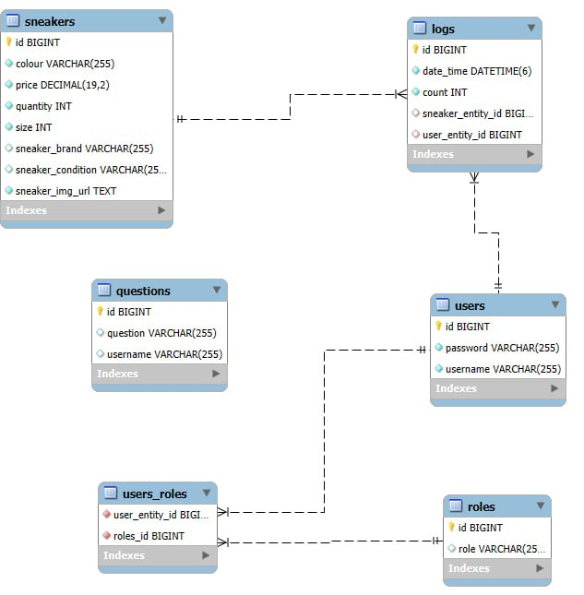

Illustration 1: Entity Relationship Diagram

## 2.3 Tables in the Database

Further information on the name, data type and description of the fields in the database and in the Java code can be found in the tables below.

**2.3.1 Table users**

|  |  |  |  |  |  |
| --- | --- | --- | --- | --- | --- |
| Name in the Database | Type in the Database | Java Name | Java Data typ | Not Null | Description |
| id | BIGINT(20) | id | Long | true | Primary key that increments automatically. The value is generated automatically by MySQL. |
| username | VARCHAR(255) | userName | String | true | Username |
| password | VARCHAR(255) | password | String | true | Password |

**2.3.1.1 Primary Key:**

* id

**2.3.1.2 Foreign Key:**

* In this table, the id field is used as a foreign key.

**2.3.1.3 Notes on the table**

This table contains information about the users of the WEB application. The main key of the table is id (the ID of the user). The database column is of data type Long. Each time a new data record is created, the value of the field is automatically incremented. This is a unique value. This means that each user is assigned a unique identifier. The user name of the newly created user is entered in the User name database field. The third field is password, which stores the user's password. The Id field is also a foreign key to another table, which shows which role this customer has. More information about this is explained in the practical solution of the task.

**2.3.1.4 SQL-Code**

CREATE TABLE `users`

(

`id` bigint(20) NOT NULL AUTO_INCREMENT,

`username` varchar(255) NOT NULL,

`password` varchar(255) NOT NULL,

PRIMARY KEY (`id`));

**2.3.2 Table users_roles**

|  |  |  |  |  |  |
| --- | --- | --- | --- | --- | --- |
| Name in the Database | Type in the Database | Java Name | Java Datentyp | Not Null | Description |
| user_entity_id | BIGINT(20) | id | Long | true | ID of the User |
| roles_id | BIGINT(20) | id | Long | true | ID oft he Role |

**2.3.2.1 Primary Key:**

There are no primary keys in this table.

**2.3.2.2 Fremdschlüssel /Foreign Keys/:**

* There are no foreign keys in this table.
* **2.3.2.3 Notes on the Table**

The main task of this table is to create a relationship between two other tables that provides information about which user has which role. The two fields are of type Long and represent the links between the two tables.

**2.3.2.4 SQL-Code**

CREATE TABLE `users_roles`

(

`user_entity_id` bigint(20) NOT NULL,

`roles_id` bigint(20) NOT NULL,

);

**2.3.3 Table sneakers**

|  |  |  |  |  |  |
| --- | --- | --- | --- | --- | --- |
| Name in the Database | Type in the Database | Java Name | Java Datentyp | Not Null | Description |
| id | BIGINT(20) | id | Long | true | Primary key that increments automatically. The value is generated automatically by MySQL. |
| colour | VARCHAR(255) | colour | String | true | Type of the Colour |
| price | DECIMAL(19,2) | price | BigDecimal | true | Price of the Shoe |
| quantity | INTEGER(100) | quantity | Integer | true | Quantity |
| size | INTEGER(20) | size | int | true | Size of the Shoe |
| sneaker_brand | VARCHAR(255) | sneakerBrand | ENUM | true | Brand oft he Shoe |
| sneaker_condition | VARCHAR(255) | sneakerCondition | ENUM | true | Condition of the Shoe |
| sneaker_img_url | TEXT | sneakerImgUrl | String | true | Image of the Shoe |

**2.3.3.1 Primary Keys:**

* id

**2.3.3.2 Foreign Keys:**

* There are no foreign keys in this table.

**2.3.3.3 Notes on the Table**

This table contains information about the shoes that have been created in the application. The primary key for this table is id (the ID of the shoes). The column in the database is of the integer data type. The value of the field is automatically incremented each time a new shoe is created and is always unique. The other columns of this table are color, price, quantity, size, sneaker_brand, sneaker_condition, sneaker_img_url, where the possible values for the SneakerBrand are Nike, Adidas, Jordan, for the SneakerCondition - UNWORN, WEARABLE, WORKONLY. In the database, all these two columns have the SQL data type ENUM, which was converted into a string in the Java code using the @Enumerated(EnumType.STRING) annotation. Further information that can be taken from this table is that the field for the shoe image must be saved in text format and a link to the image must be transmitted. At the moment, the app supports the three shoe brands shown. This could easily be expanded at a later date, but to ensure the authenticity of the program, only these brands are offered for the time being.

**2.3.3.4 SQL-Code**

create table sneakers (

id bigint not null auto_increment,

colour varchar(255) not null,

price decimal(19,2) not null,

quantity integer not null,

size integer not null,

sneaker_brand varchar(255),

sneaker_condition varchar(255),

sneaker_img_url TEXT not null,

primary key (id)

)

**2.3.4 Table questions**

|  |  |  |  |  |  |
| --- | --- | --- | --- | --- | --- |
| Name in the Database | Type in the Database | Java Name | Java Datentyp | Not Null | Description |
| id | BIGINT(20) | id | Long | true | Primary key that increments automatically. The value is generated automatically by MySQL. |
| username | VARCHAR(255) | username | String | true | Username |
| question | VARCHAR(255) | question | String | true | Question of the User |

**2.3.4.1 Primary Keys:**

* id

**2.3.4.2 Foreign Keys:**

* There are no foreign keys in this table.

**2.3.4.3 Notes on the Table**

This is another main table in the database system. It contains information on the questions offered by the users. The primary key for this table is id (the ID of the service). The column in the database is of the integer data type. The value of the field is automatically incremented each time a new service is registered and each question has a unique id. The other columns are username and question. The purpose of this table is to store values about which user has asked a specific question about the app or a specific pair of shoes, and the question field contains exactly this information

**2.3.4.4** **SQL-Code**

CREATE TABLE `questions`

(

`id` bigint(20) NOT NULL AUTO_INCREMENT,

`username` varchar(255) NOT NULL,

`question` varchar(255) NOT NULL,

PRIMARY KEY (`id`)

)

**2.3.5 Table logs**

|  |  |  |  |  |  |
| --- | --- | --- | --- | --- | --- |
| Name in the Database | Type in the Database | Java Name | Java Datentyp | Not Null | Description |
| id | BIGINT(20) | id | Long | true | Primary key that increments automatically. The value is generated automatically by MySQL. |
| date_time | DATETIME(6) | dateTime | LocalDateTime | true | Date and time of publication of the offer |
| count | integer | count | int | true | Number of pairs of shoes |
| sneaker_entity_id | BIGINT | sneakerEntity | SneakerEntity | true | Foreign key, corresponds to id in sneakers table. |
| user_entity_id | BIGINT | userEntity | UserEntity | true | Foreign key, corresponds to id in users table. |

**2.3.5.1 Primary Keys:**

* id

**2.3.5.2 Foreign Keys:**

* sneaker_entity_id – This table corresponds to id in “sneakers” table
* user_entity_id – This table corresponds to id in “users” table

**2.3.5.3** **Notes on the Database**

The date_time field ensures that the correct time range is maintained when an admin user has entered a new entry for a pair of shoes. The count field contains information about how many copies of a particular pair of shoes are available. The other two fields, sneaker_entity_id and user_entity_id, are foreign keys and provide the link between the respective tables so that there is a match between a sneaker ID and a user ID.

This table is important for the application as it contains information about who changed the stock, when and how. This makes it easier to track events and enables statistics to be kept, which is actually implemented, but more on this below.

**2.3.5.4** **SQL-Code**

create table logs (

id bigint not null auto_increment,

date_time datetime(6) not null,

count integer not null,

sneaker_entity_id bigint,

user_entity_id bigint,

primary key (id)

)

**2.3.6 Table roles**

|  |  |  |  |  |  |
| --- | --- | --- | --- | --- | --- |
| Name in the Database | Type in the Database | Java Name | Java Datentyp | Not Null | Description |
| id | BIGINT(20) | id | Long | true | Primary key that increments automatically. The value is generated automatically by MySQL. |
| role | ENUM | role | UserRoleEnum | true | User Roles |

**2.3.6.1 Primary Keys:**

* id

**2.3.6.2 Foreign Keys:**

* There are no foreign keys in this table.

**2.3.6.3** **Notes on the Table**

This table actually provides information about the roles of the users of the application. The primary key is id and is incremented automatically, and the other field contains information about possible roles of users in the app, each of the type string.

**2.3.6.4 SQL-Code**

create table roles (

id bigint not null auto_increment,

role varchar(255),

primary key (id)

)

## 2.4 Explanation of the REST API

An application programming interface (API) is a set of definitions and protocols for the creation and integration of software applications. It is sometimes referred to as a contract between an information provider and an information user, specifying the content that the consumer must provide (the call) and the content that the producer must provide (the response). For example, the API design for a weather service might require the user to provide a postal code and the provider to respond with a two-part response, the first part of which is the maximum temperature and the second part of which is the minimum temperature.

In other words: If you want to connect to a computer or system to retrieve information or perform a function, you can use an API to submit your request to the system so that it can understand and respond to it.

An API can be seen as an intermediary between users or customers and the desired resources or web services. It is also a mechanism for an organization to exchange resources and information while maintaining security, control and authentication - the ability to determine who has access to what.

REST APIs can be written in almost any programming language and process a wide range of data types. The only requirement is that they adhere to the six REST design principles (also known as architectural constraints) listed below:

1. Uniform interface - Regardless of where the request comes from, all API requests for the same resource should look the same. The REST API should ensure that the same data, such as a user's name or email address, is associated with only one uniform resource identifier (URI). The resources should not be overly large, but they should contain all the information the customer needs.
2. Client-server decoupling - Client and server applications must be completely independent of each other in the REST API architecture. Only the URI of the requested resource should be known to the client program; it cannot communicate with the server application in any other way. Similarly, a server application should not modify the client program except to provide it with the required data via HTTP.
3. Statelessness - REST APIs are stateless, i.e. each request must contain all the data required for processing. In other words, REST APIs do not require server-side connections. Any data associated with a client request must not be stored by server applications.
4. Cacheability - If possible, resources should be cacheable on the client or server side. Server responses must also contain information as to whether caching is permitted for the delivered resource or not. The aim is to increase speed on the client side and at the same time improve scalability on the server side.
5. Layered system architecture - The calls and responses in REST APIs pass through several levels. As a rule, you should not expect client and server programs to communicate directly with each other. There may be several different intermediate stages in the communication loop. REST APIs must be developed in such a way that neither the client nor the server can determine whether they are communicating with the final application or with an intermediary.
6. Code on demand - Although REST APIs usually provide static resources, the responses may also contain executable code (such as Java applets) under certain circumstances. The code should only be executed if required and in certain situations.

# CHAPTER III:

# Practical Solution to the Problem

The entire structure of the application is presented in the third chapter of the bachelor thesis. The many functions of the Sneaker Shop are explored and explained one by one. The logic behind the function will be demonstrated using Java, JavaScript and Spring, as well as the user interface, which will be demonstrated using HTML5, CSS3, Bootstrap and Thymeleaf. In a few words, it will explain several information about the communication between backend and frontend and how the fictionality of this application was achieved with these technologies.

## 3.1 Implementation of the functionality for Logging In

There are two options for a user - either log in with an existing account or register and create a new account and then log in.If a user wants to use the application, they must be logged in. The login page is displayed via the Thymeleaf html /auth-login page. If the user logs in successfully, they will be redirected to the /home page and can access the various panel options as shown below. If they are unable to log in, they can go to the /auth-register page and create a new account.

The Spring security configuration ensures that only an ADMIN user can access the function to add a new sneaker. Otherwise, if a user only has the USER role, they can only access the listing of all sneakers and the ordering of a sneaker.

Before going deeper into the main functionality of this application, adding shoes and shopping different pairs of shoes, an important part is the authentication process when logging in and also registering. So now it will be explained in a few words.

The loginAndRegisterUser method is a central component for the registration and login of a user in the web application. It performs several important tasks, including saving a new user in the database, assigning user roles and automatically authenticating the new user.

A good practice is to decrypt the user's password and not store it as plain text in the database. Encryption is an important aspect of database security. Encryption secures the actual data in the database and protects the backups. This means that the data remains protected even in the event of a data breach. Figure 2 shows the encryption process. In our case, Bcrypt password encoder is used, which is based on the Blowfish cipher. Bcrypt uses an adaptive hash algorithm to store the password. The hash algorithm is actually a one-way function that creates a fingerprint of the input, but there is no way to go back to the original input. This means that if the database containing the user's personal data is exposed by an attacker, the hacker can only see the encrypted password and cannot access the original password.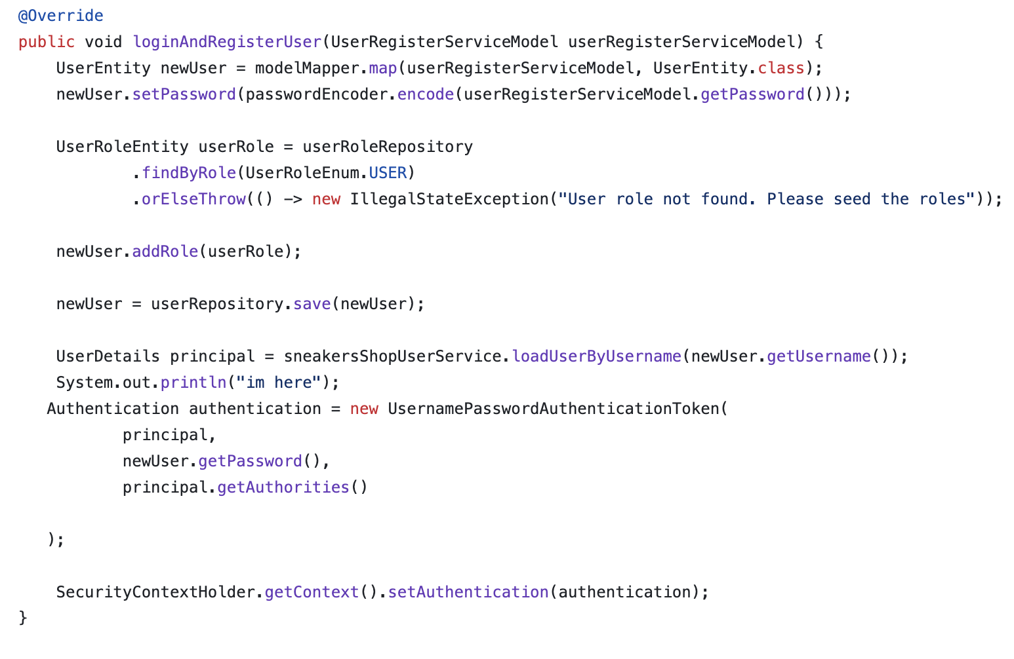

**Illustration 2: Encryption of the Password**

The method in line 4 searches for the default role USER in the table for user roles (userRoleRepository). findByRole is a query based on the UserRoleEnum.USER. If the role is not found, an IllegalStateException is thrown.

Reason: Each user must have at least one role in order to define the authorizations in the application. The “seeding” of the roles ensures that the necessary roles exist when the application is initialized.

After saving, the user information is loaded using the loadUserByUsername method. This method is part of the Spring Security UserDetailsService and returns a UserDetails object.

Reason: Spring Security requires a UserDetails object to perform authentication and authorization processes. Further details on the Spring Security implementation are described below.

A UsernamePasswordAuthenticationToken is also created, which contains the user's login data (user name, password, roles).

Parameters:

principal: The user details (contains user name, password and roles).

newUser.getPassword(): The hashed password of the user (from the database).

principal.getAuthorities(): The roles or authorizations of the user.

Reason: This token is used by Spring Security to authenticate the user in the security context.

The last line is used to save the user's authentication in the security context.

The SecurityContextHolder saves the current authentication status of the user.

The setAuthentication method sets the authentication for the current user, whereby the user is considered logged in.

Reason: This allows the user to access protected resources of the application immediately after registration without having to log in again manually.

When a user makes a request for user authentication with their credentials, the server generates an encrypted token in the form of a JWT and sends it back to the client. When a client receives a token, it means that the user has been authenticated to use the client for any action.

When a user requests data from the server or performs any activity for that website, the JWT is stored on the client side, generally in localStorage or using a cookie, and it is delivered as that user's unique key. When the server receives the request, it checks the JWT for each request to ensure that it is only for that particular user and then returns the required response to the client.

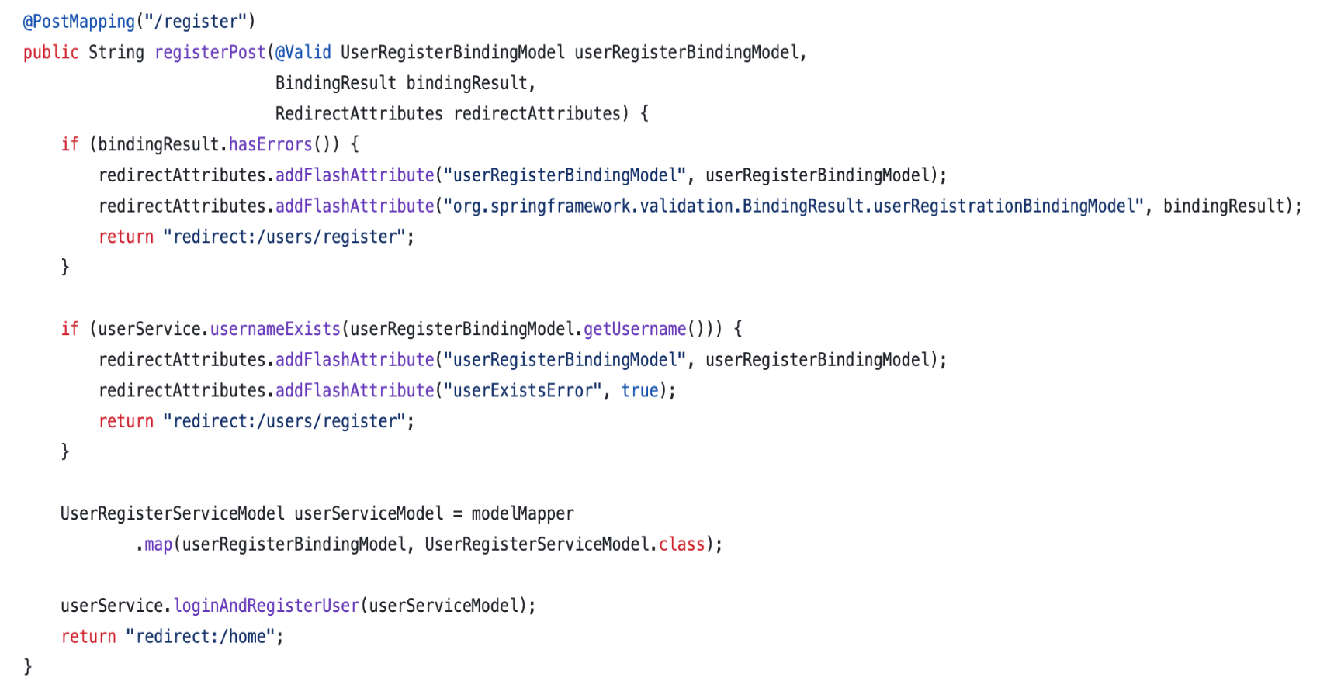 Here is also the code fragment how this is done.

**Illustration 3: Login function in Java backend**

The @Valid annotation instructs Spring to validate the data passed to the controller by checking all attributes of the entity with annotations such as @Positive, @NotNull etc.. So if there is an inconsistency in the username and password, a custom exception like InvalidEntityException is thrown, so the user has to re-enter their credentials. If everything is OK with the input data, a JWT token is generated. The purpose of using JWT is not to hide data, but to ensure the authenticity of the data. JWT is signed and encoded, not encrypted. JWT is a stateless authentication mechanism on a token basis. Since it is a client-side stateless session, the server does not need to rely entirely on a data store (database) to store session information. The bindingResult parameter contains the result of the validation of the transferred UserRegisterBindingModel.Wenn die Validierung fehlschlägt (z. B. weil Pflichtfelder nicht ausgefüllt sind oder ungültige Werte eingegeben wurden), wird der Benutzer zurück zur Registrierungsseite geleitet.

addFlashAttribute saves the entered data and validation errors in the RedirectAttributes so that they are available on the target page (registration form).

In this way, the user's entries are retained and errors can be displayed to the user on the form page.

For a registration page to work properly, it must be checked that the name with which a user wants to register does not already exist. Therefore, a logic has been implemented that checks exactly this. The userService.usernameExists method checks whether the user name already exists in the database.

If the username exists, addFlashAttribute saves the binding model and adds a special error message (userExistsError). At the end, the user is redirected back to the registration page.

Purpose: To prevent multiple users from registering the same user name.

The loginAndRegisterUser method takes over the registration of the user (saving in the database) and automatically performs a login. Details have already been explained in the previous method.

Purpose: To log the user in directly after successful registration in order to increase user-friendliness.

After successful registration and login, the user is redirected to the start page of the application.

The navigation of this application looks in different ways and it depends on whether the user is logged in and whether he is a USER or an ADMIN. Figure 5 shows the appearance of the navigation when the user is not logged in. In this situation, the buttons for registering and logging in are still visible and active. It should also be noted that if the user wants to add a new offer, they will be taken directly to the login page to enter their login details.



**Illustration 5: Navigation for a user who is not logged in**

Figure 6 shows that the navigation looks a little different. This also means that several functions are made available to the user in this situation. In this case, the user has the option of viewing all offers, ordering an offer, asking a question or submitting a petition and logging out of the application.



**Illustration 6: Navigation for a logged-in user**



**Illustration 6.1: Navigation for a logged-in admin user**

To achieve this, we need to make sure that the application context is set up and working correctly. This is done in the aforementioned loginAndRegisterUser method, after line 58.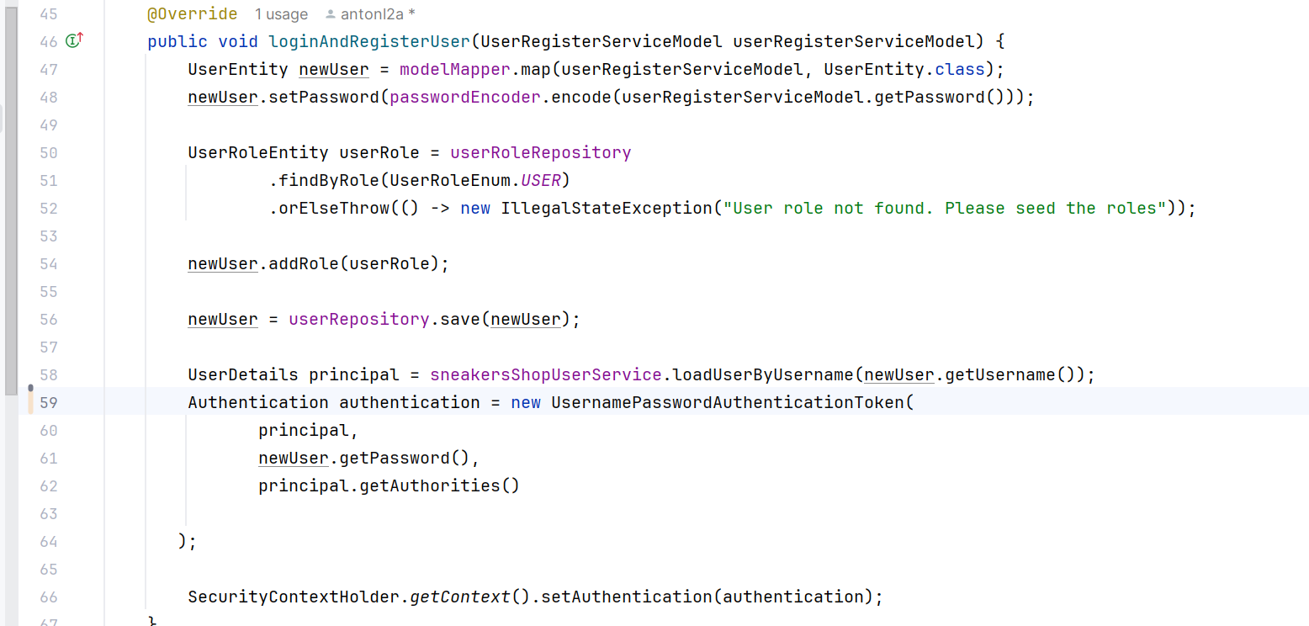

**Illustration 7: The ApplicaitonContext in the Application.**

The code shown is used to manually authenticate a user and enter their authentication status in the security context of Spring Security. First, the user data is loaded from a UserDetailsService. This is done using the loadUserByUsername method, which returns a UserDetails object. This object contains important information such as the user name, password and the roles or authorizations of the user. This data is essential as it provides Spring Security with the basis for authentication and authorization.

After loading the user data, a new authentication token of the type UsernamePasswordAuthenticationToken is created. This token represents the authentication status and includes the user information (principal), the password and the user's authorizations (principal.getAuthorities). The token serves as a central unit for tracking the security status of a user within the application.

The token is then stored in the SecurityContextHolder, which manages the security context for the entire application. By setting the token, the user is marked as authenticated and this information is available for the current session. All further security checks within the application, e.g. for access to protected endpoints, use this security context to verify the user's authentication and authorization information.

This mechanism is often used to automatically log in users directly after an important action such as registration or password change. This improves the user experience as no separate login is required. Instead, the user is seamlessly authenticated and can immediately access protected areas of the application.

Props are used to send data from top to bottom (parent to child) in a normal React application. However, this can be inconvenient for certain types of props (e.g. area setting, UI theme) that are required by multiple components within an application. Context allows components to communicate such values without having to send a prop directly through each level of the tree.

Wenn der Benutzer also angemeldet ist, wird dieses Objekt in unserem Kontext gespeichert sein.So kann man auf diese Weise sehr leicht das eingeloggte Objekt aus dem Kontext in dem gesamten Ablauf unserer Anwendung abrufen. So wenn der Wert von diesem Object null ist, bedeutet das, dass kein Benutzer in diesem Moment angemeldet hat. So muss in diesem Fall die entsprechende Navigation gezeigt werden.

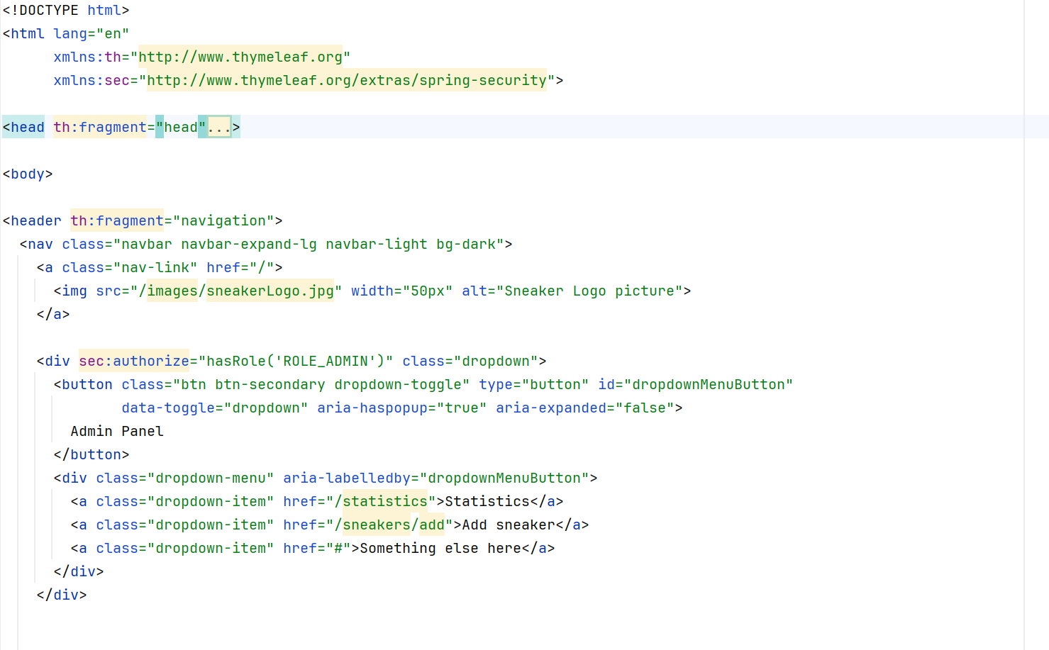

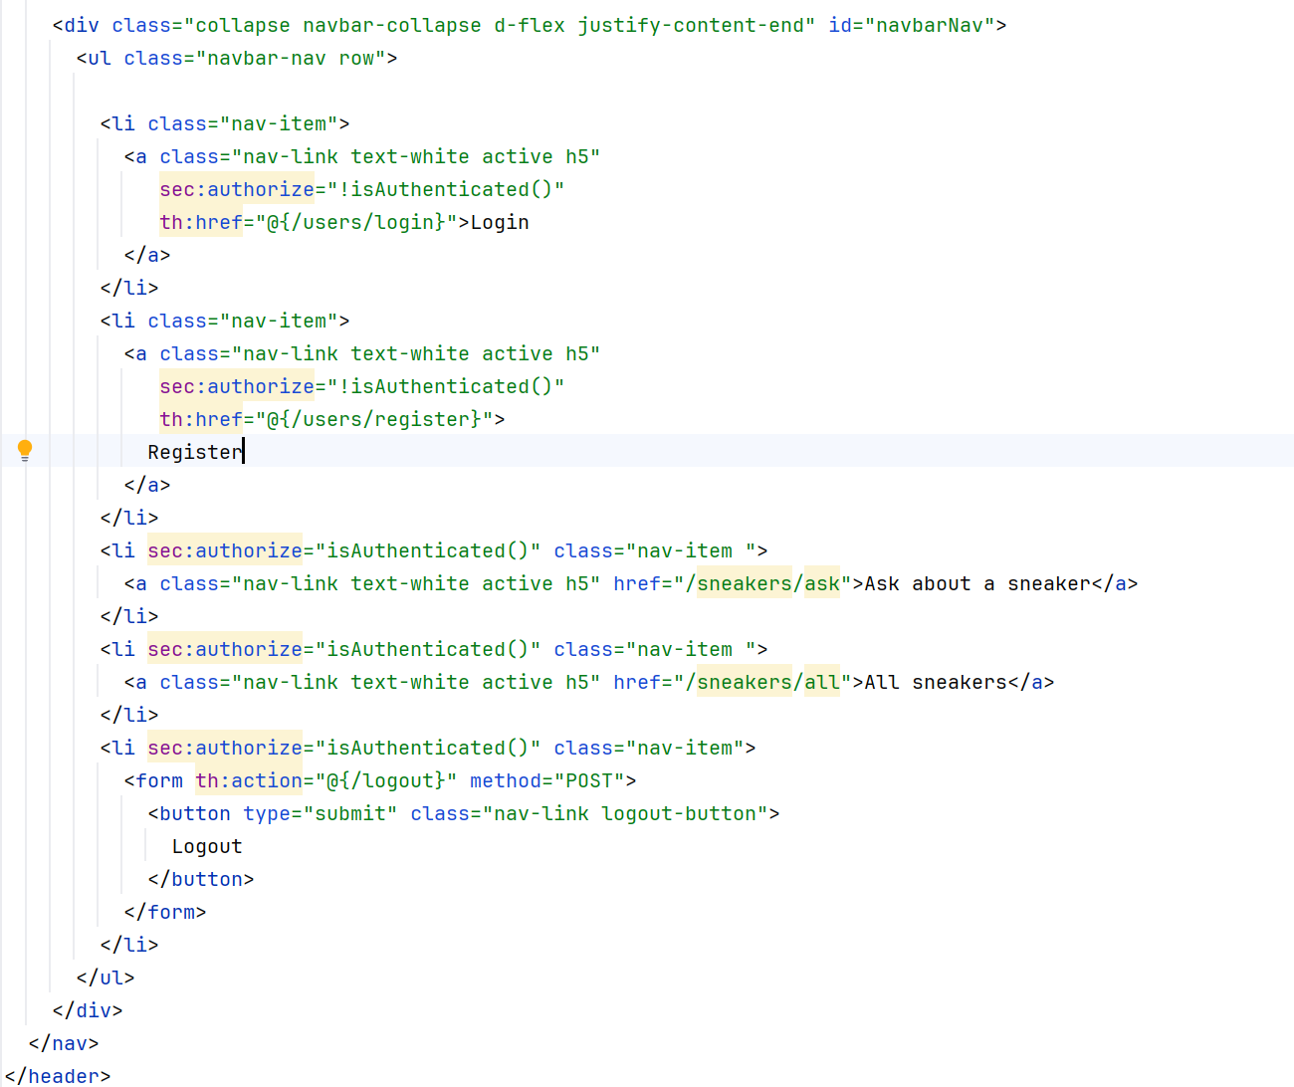

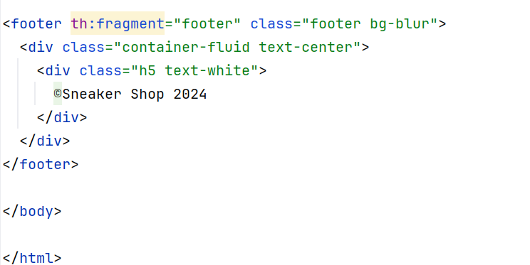

**Illustration 8, 9, 10: Fragment component – Header, Footer and Navigation**

## 3.2 Implementation of functionality for access to all shoes

In the first step of creating an offer, the user must select a pair of shoes that is already available. The system should provide a list of all shoe pairs created in the database. This is made possible by a JPA repository in the backend. First, an interface with the name SneakerRepository is declared, which inherits a JPA repository.



**Illustration 11: Sneaker Repository Declaration**

This interface has many embedded methods. An example of such a method, which is used here, is findAll(). The following method getSneakers() is implemented in the sneaker service: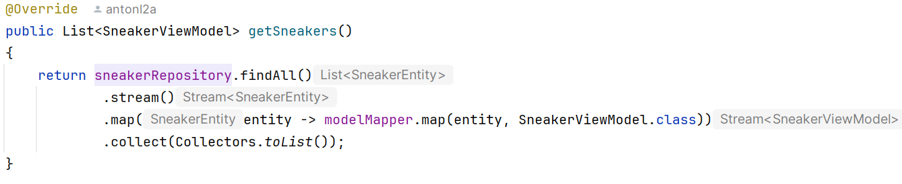

**Illustration 12: Implementation of getSneakers – Method**

This source code example shows how to use the findAll() method in Spring Data JPA to fetch or retrieve all entities from the database. As the name suggests, we can use the findAll() method to retrieve all entities from the database table.

The equivalent in SQL code will be the following:



**Illustration 13: SQL-Snippet – to select all Shoes**

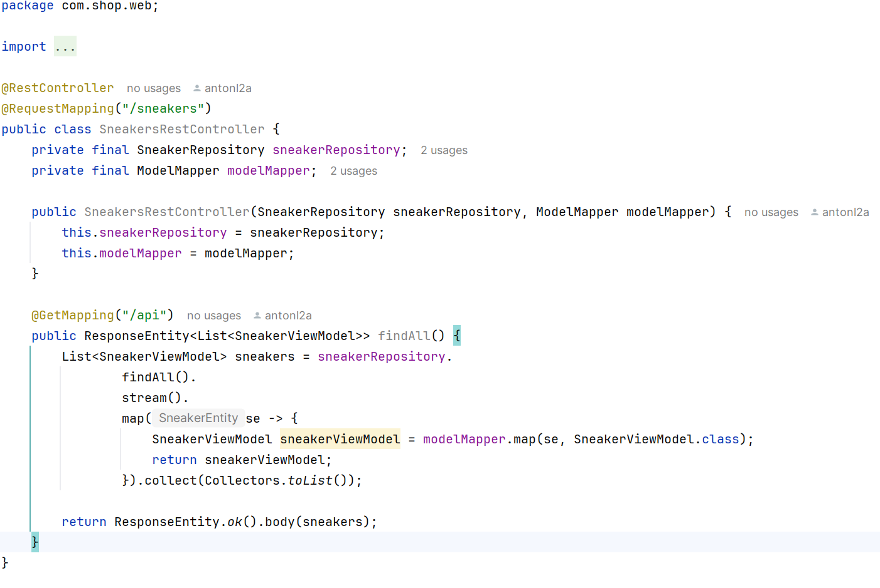

**Illustration 14: Implementation of Sneakerscontroller**

First, it is good to explain the annotation - @RestController. The @Controller and @ResponseBody annotations of the Spring RestController annotation are themselves annotated with @Controller and @ResponseBody. This annotation is used to identify a class as a request handler. The RestController annotation in Spring MVC is used for the development of RESTful web services.

The implemented method is provided with the annotation @GetMapping so that the HTTP request is mapped to the specific handler method. The endpoint is also declared here - /api. This endpoint must be accessed by the front-end application so that all markers are displayed in the user interface.

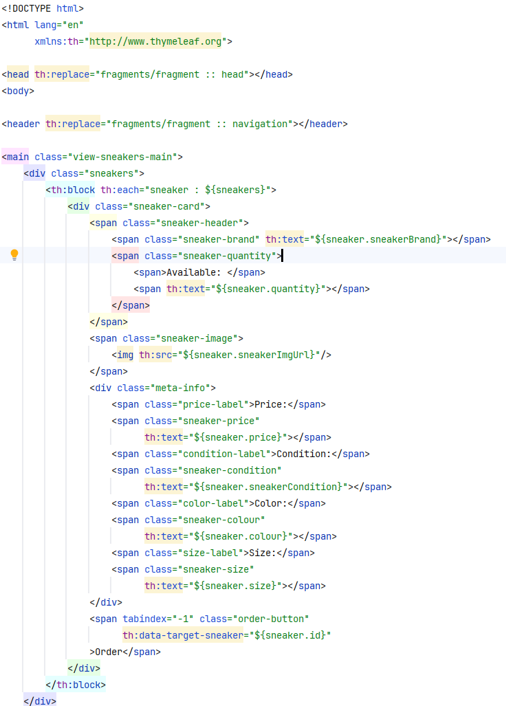The next section describes how this is done at the front end. In the service implementation method, each entity of a sneaker found in the database is mapped to a sneaker view model with the sole purpose of providing this collection of view sneaker entities to the thymeleaf rendering tool and visualizing them 1 to 1 in the frontend. The HTML page used to visualize the sneakers is sneakers-list:

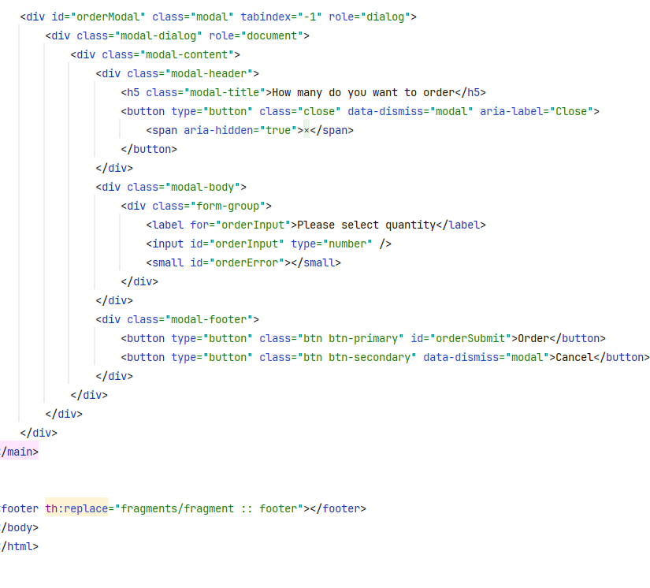

**Illustration 15: Implementation of getAllSneakers() and sneakers-list.html in Thymeleaf**

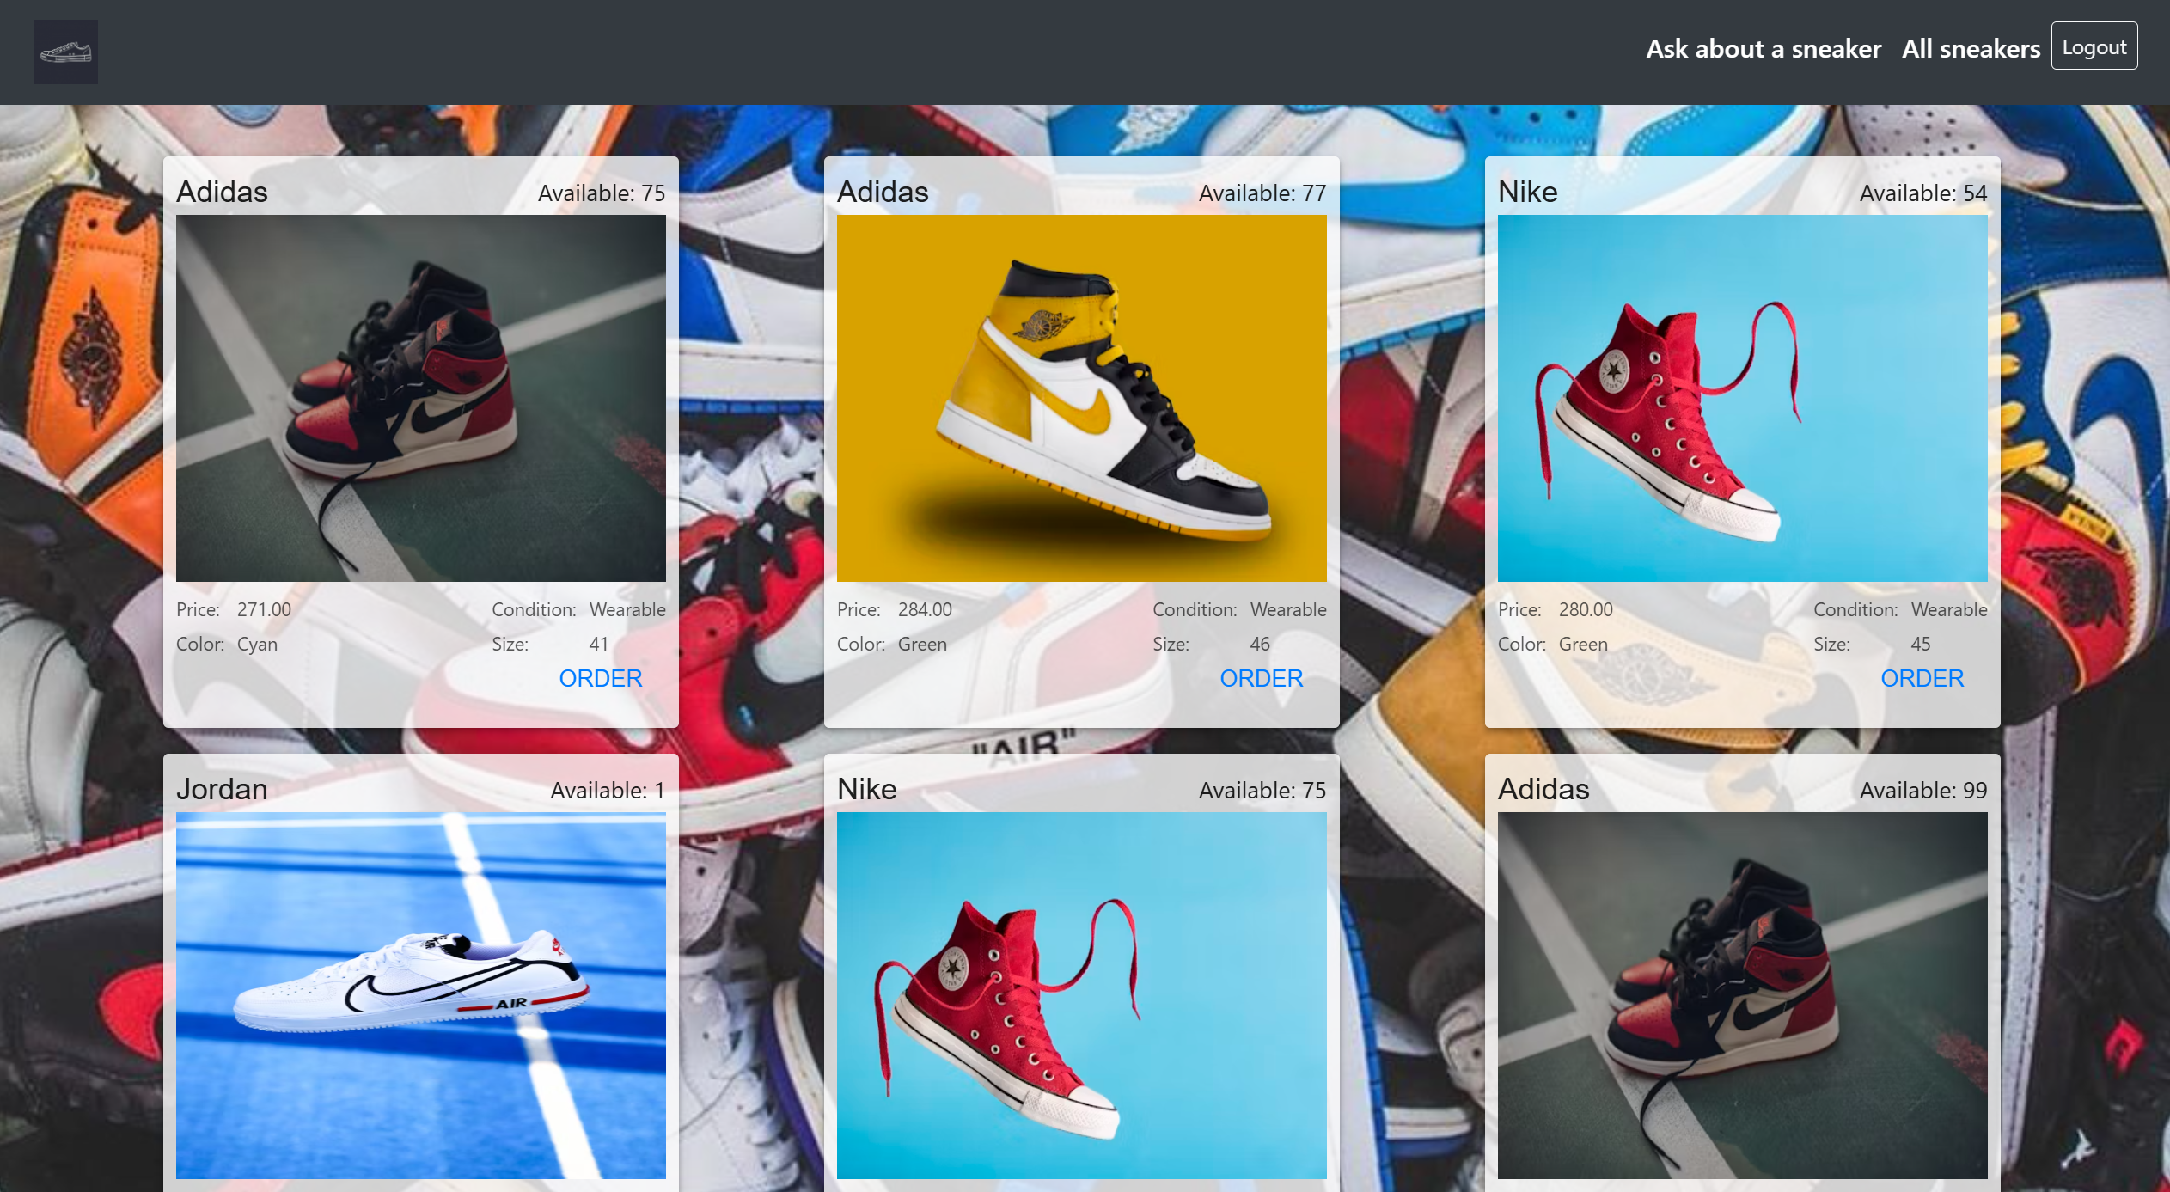

**Abbildung 16: List with all Sneakers Pairs**

To display all shoes, Thymeleaf is used, as can be seen from Figure 13. In the thymeleaf sneaker-list html page, Thymeleaf ensures that the fragment.html is included in the current page, i.e. the header, footer and navigation are displayed. Then the page with each individual sneaker view model is set up so that each is displayed in a separate box with details on price, color, brand, size, etc.

The th:block thymeleaf tag is used to get each individual sneaker view model and render it separately. With th:text we get all the properties of the entity and render them accordingly, such as price, color and size.

## 3.3 Implementation of the functionality of adding a new pair of sneakers

An important and inseparable part of this application is the addition of different pairs of shoes. The admin user can enter the offer details in a form in the user interface. They are assigned to his user name. The input form has the following design: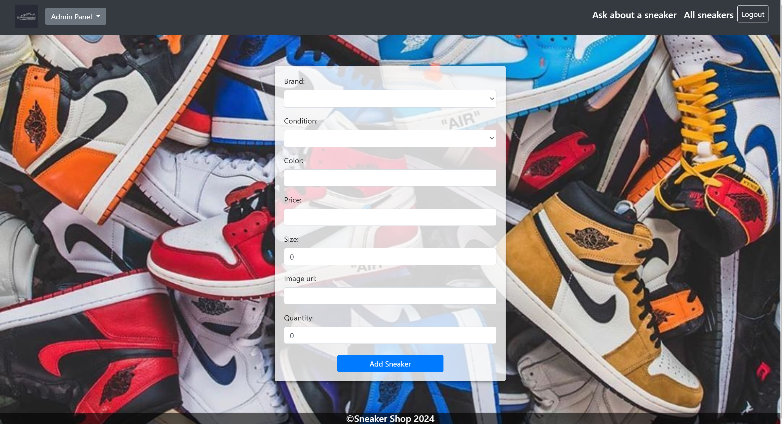

**Illustration 17:** **Adding pairs of shoes**

This functionality is only available for an admin user. This means that a logged-in user with the User role cannot use this functionality. If a user is logged in as an admin, they will see this functionality in the navigation bar as 'Add Sneaker':

All fields of this form are mandatory. And if one of the fields is left blank when submitting the form, an error message will be displayed stating that the specific field is required. The Brand is a dropdown with the available brands. How these models are retrieved from the database is already explained in the 3.2 point of this bachelor thesis. The other field for Condition is also a dropdown Mеnu. These two fields are actually enums. An enum type is a special data type that allows a variable to consist of a series of predefined constants. The variable must be equal to one of the predefined values for it. For example, for the brand the possible values are: Nike, Jordan, Adidas.

The parameters entered by the user for the offer are sent to the server using a POST request. A Java method then creates a new entry in the database, which is assigned to the user. Figure 17 is the implementation of this method. If a user enters all parameters correctly in the form, a post method with an endpoint “/add” is called. The body that comes from the frontend is of type SneakerAddBindingModel. There are validators for each property of this entity. When the add method is called, this binding model is then mapped to a SneakerAddServiceModel, which our application can work with and ultimately store in the database.

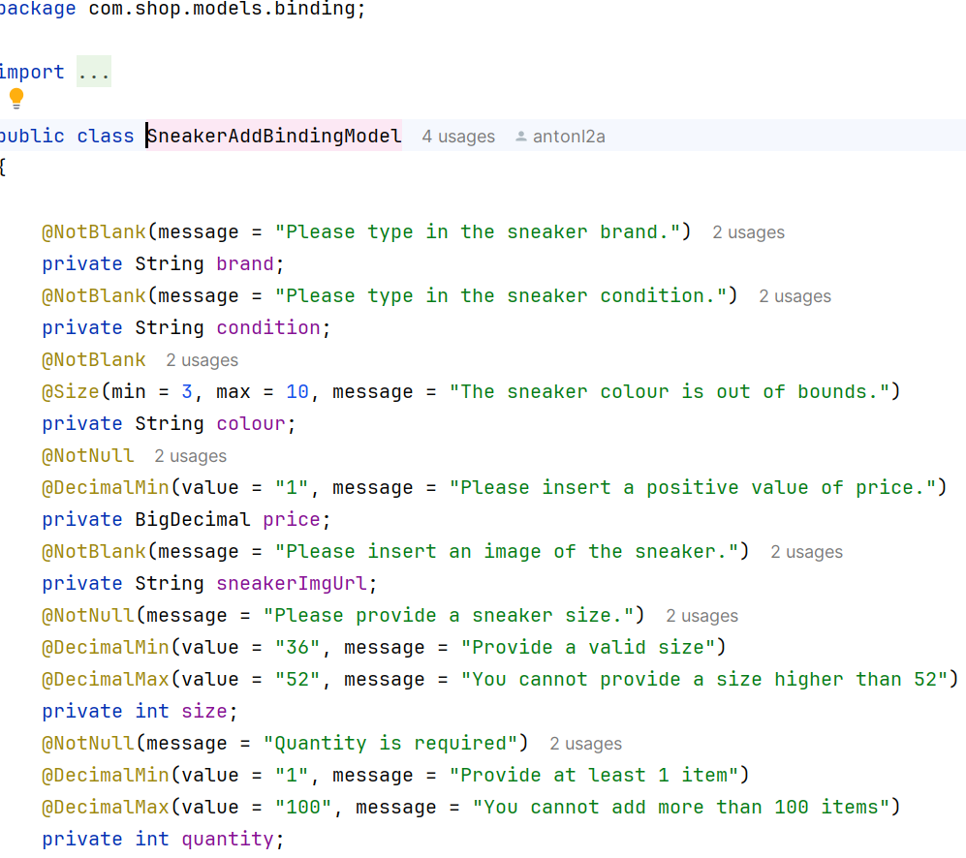

**Illustration 18:** **The view model of a sneaker**

One interesting thing to observe here is the use of an instance of ModelMapper. The goal of ModelMapper is to simplify object mapping by automatically determining how to map one object model to another based on conventions, just as a human would - while providing a simple, refactorable API for handling specific use cases. With the help of the model mapper, it is very easy to convert a SneakerAddServiceModel entity to SneakerEntity.

A data transfer object (DTO) is an object that transfers data between processes. This technique is used to facilitate communication between two systems (e.g. an API and your server) without potentially revealing sensitive information.

When all fields are filled in and all data is successfully saved to the database, the user is redirected to the main page where all shoes are listed.

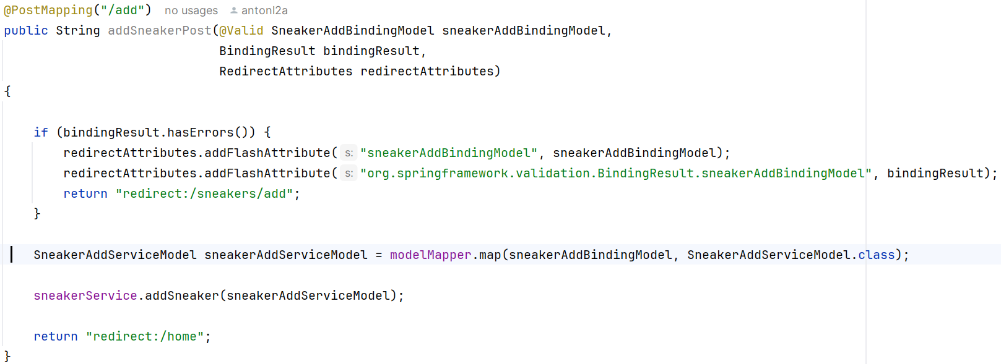

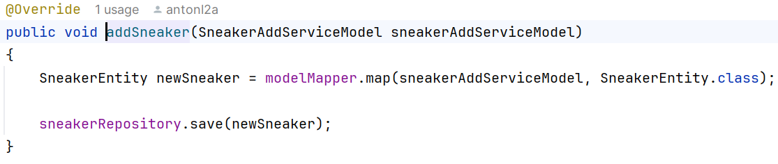

**Illustration 19: Implementation of addSneaker-Method**

## 3.4 Implementation of the functionality for shopping and deleting pairs of shoes

Once the user has created an offer, he is redirected to the main page of our application where all available offers are accessible. In addition, each offer has a purchase button.

In the individual fields of the available sneakers, users can find out more about the product and order it using the “ORDER” button. The user has the opportunity to make a better decision for himself whether this offer suits him. How the main page of offers of our application can be seen in Figure 20.

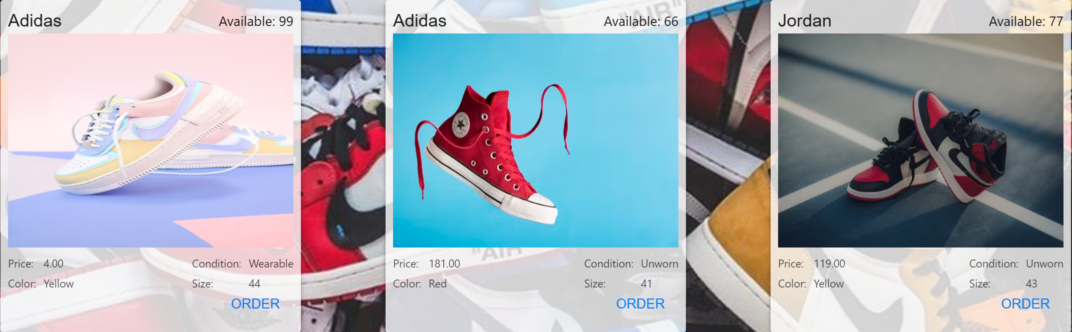

**Illustration 20: All Sneakers**

The user is also free to edit or delete his own offers if he wishes.

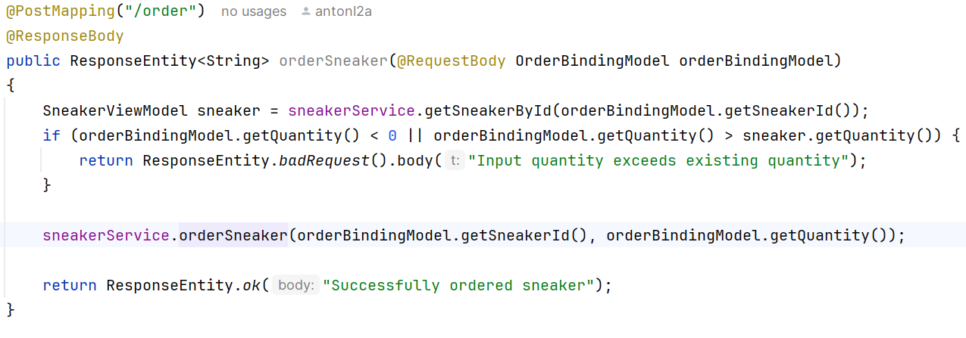

**Illustration 21: Implementation of Order-Method in the Controller**

One of the most commonly used annotations for mapping web requests to Spring Controller methods is the @RequestMapping annotation. @PostMapping is a special form of @RequestMapping(method = RequestMethod.POST), which can be used as a shortcut. The annotation @PostMapping is used to link HTTP POST requests with certain handler methods of a Spring controller. The HTTP POST method is typically used to create new resources. Just like @DeleteMapping, @PostMapping can only be used at method level, while the annotation @RequestMapping can be used at class level.

In the following example, the code shows an orderSnekaer handler method within the Spring controller. This method has been annotated with @PostMapping. The client can create a new offer in the database via the URL HTTP://localhost:8081/order. The body of the HTTP request is used to transmit the details of the new offer. The use of the annotation @RequestBody is relevant here in order to bind the request data into a Java object.

The first step is to check whether the sneaker exists in the database. Then it should be checked that the quantity of the ordered product does not exceed the available quantity in the database, which could lead to incorrect results. Finally, we arrive at the call to the orderSneakers service method, which performs the logic that will be explained shortly.

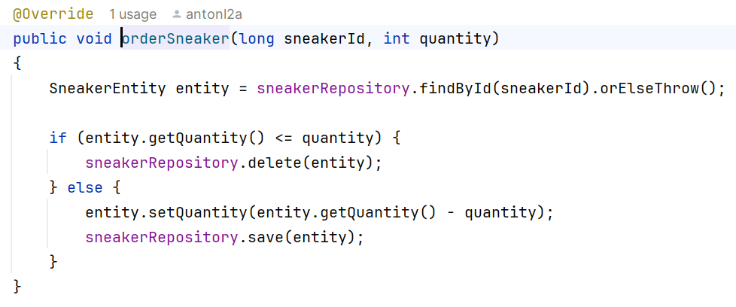

**Illustration 22: Implementation of the Order-Method**

The orderSneaker method in the service implementation handles the logic of ordering sneakers - it provides information about which sneaker was ordered, the quantity and who placed the order. Its purpose is to ensure that we work with the correct shoe in the database and finally delete it from the database. First, we retrieve the sneaker from the database using its ID. Then we check whether the sneaker ordered was the last available sneaker in the database. If this was the case, the sneaker is deleted from the database and is no longer displayed in the application listing. If it is not the last pair, we simply update the quantity value of the shoe in the database by reducing it by the desired quantity.

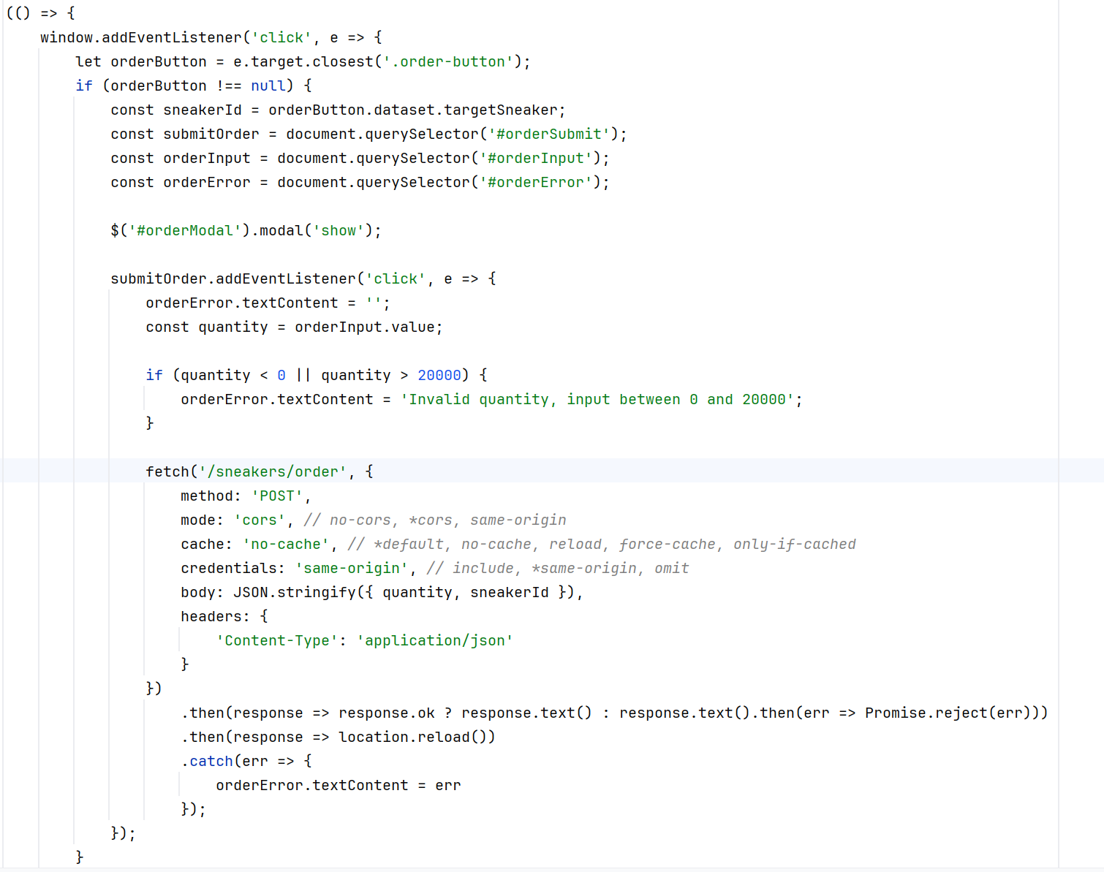

**Illustration 23: Implementation of the Order-JavaScript-Method**

I have implemented a javascript function that “listens” on this page and when a product has been ordered it should trigger the call to the Rest API “/order” endpoint which is the entry point into the order logic. The function does the job of listening, when the order button has been clicked it triggers a call to localhost:8081/order and the application continues with the backend logic I just explained.

It should be noted that when a shoe has been ordered correctly, the page is refreshed and the user is shown the listing page again.

## 3.5 Implementation of the functionality for asking questions

The ability to ask questions, submit a petition or simply get in touch with the moderators of the application is also a large and important part of this application.

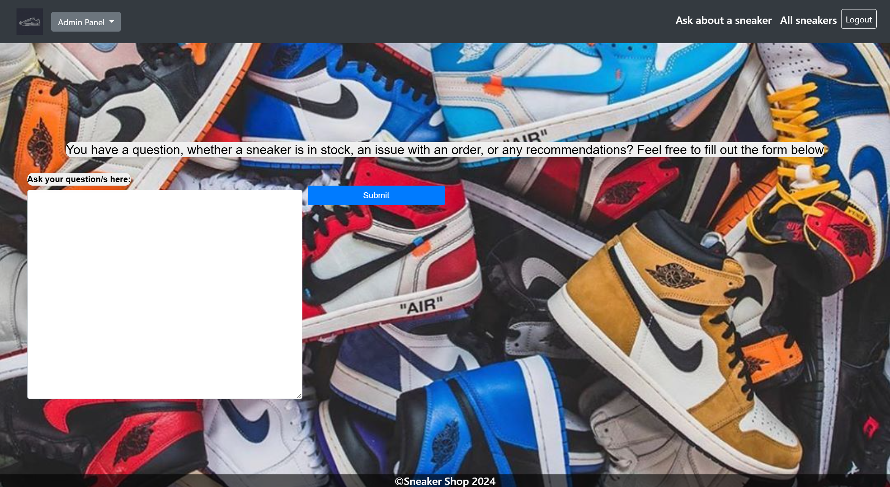

**Illustration 24: The View, where one can ask questions.**

This part of the application is again implemented using JavaScript, Thymeleaf and Spring logic. The user is prompted to formulate their question or comment, then a blue submit button appears right next to the white field. When a user clicks the button, a request is sent to the backend, which is then stored in a database for further consideration.

In the figure you can see how this file is saved locally.

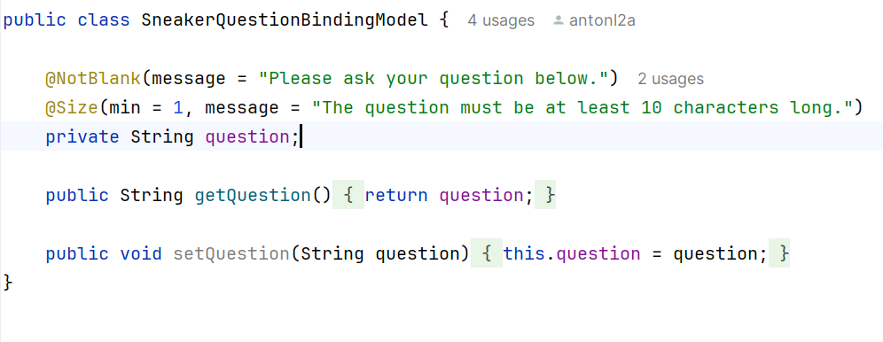

**Illustration 25: The SneakerQuestionBindingModel Entity**

The model that is sent from the frontend of the application to the backend service logic takes the form of a SneakerQuestionBindingModel. This entity is part of the Thymeleaf HTML page sneaker-question.html. There are valid checks for the question parameter of this entity both in the binding model and in the HTML page.

In the image below, you can see the Thymeleaf HTML page that handles the logic behind clicking the submit button.

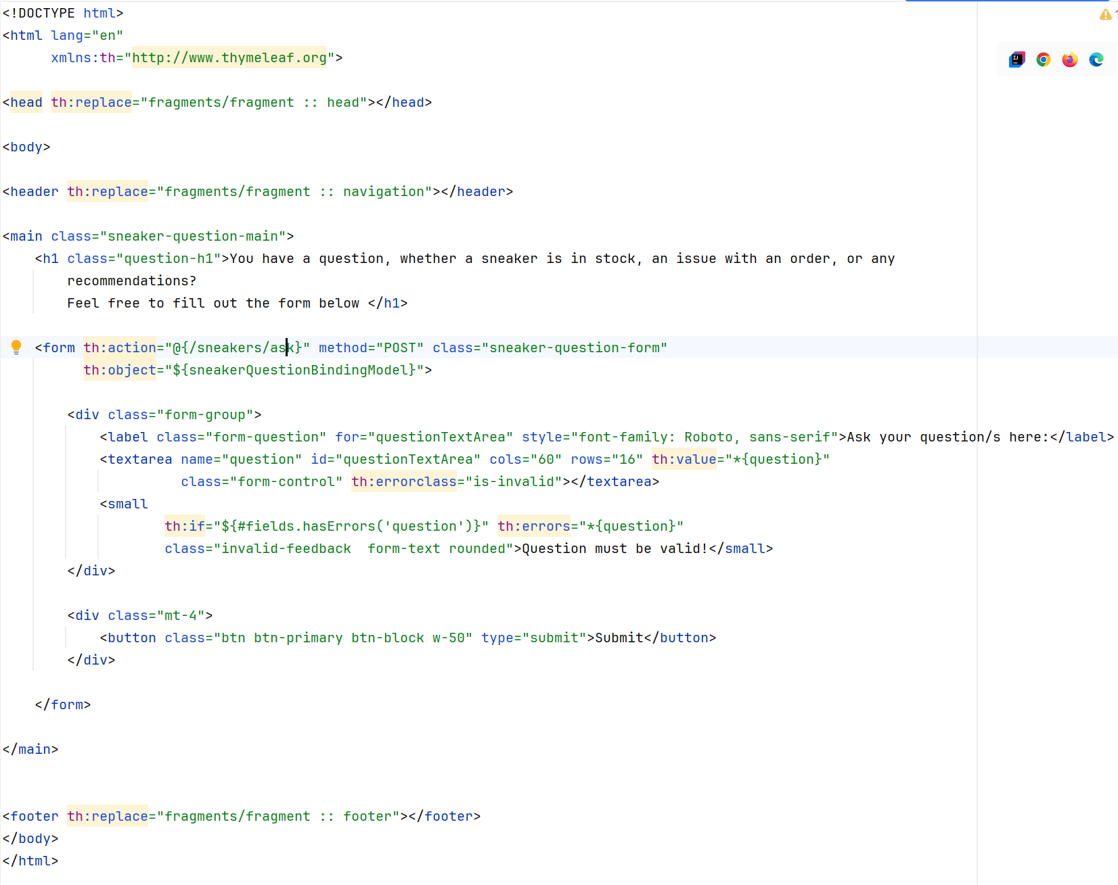

**Illustration 26: The Thymeleaf sneaker-question HTML Page**

This html page is first filled with the fragment page already handled, inserting the navigation bar, header and footer of the application, depending on the user's role - user or administrator. If you then click the Submit button to send a question, a POST request is sent to the endpoint localhost:8081/sneakers/ask. Then the application enters the controller with the endpoint /sneakers/ask and processes the logic to store the question in the database, as shown below.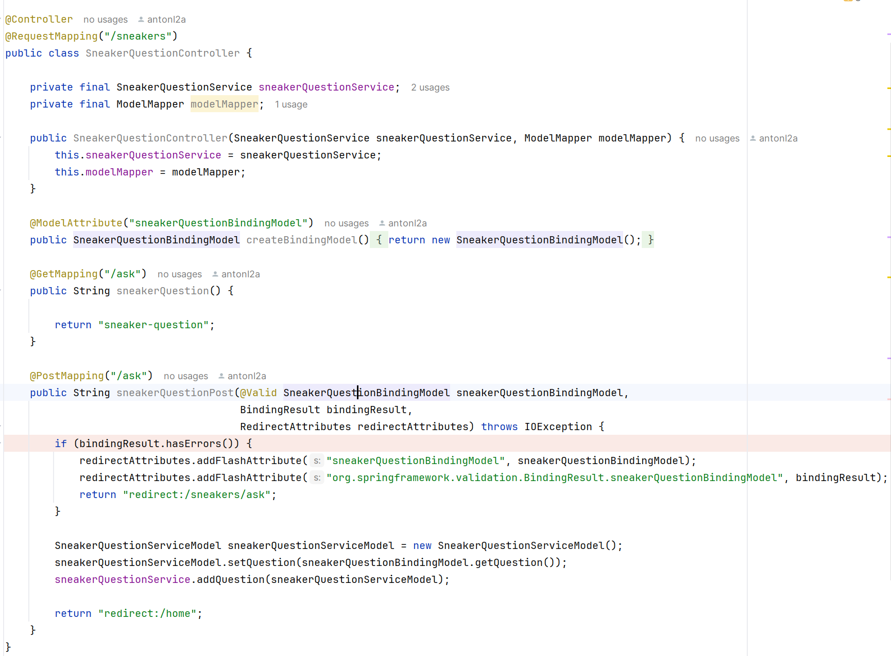

**Illustration 27: The SneakerQuestionController and the questionPost method**

Again, we see that there is a separate controller that handles the logic of receiving a question and storing it in the database. It works with a SneakerQuestionBindingModel annotated with @Valid to check if the entity in question is a valid one, which has already been described in detail in the previous section. If there are no errors, the BindingModel is mapped to a SneakerQuestionEntity, which is finally stored in the repository (the database). And finally, the user is redirected to the start page.

## 3.6 Implementation of the functionality for statistics

I have already mentioned that this application has different functions for different types of users - admin or simple user. If a user is an administrator, he gets the possibility to access the statistics part of the application, where information about when, who and what was ordered is stored.

**Illustration 28: The functionality of statistics**

When an admin user clicks on this statistics button, they are redirected to another Thymeleaf HTML page called stats.html.

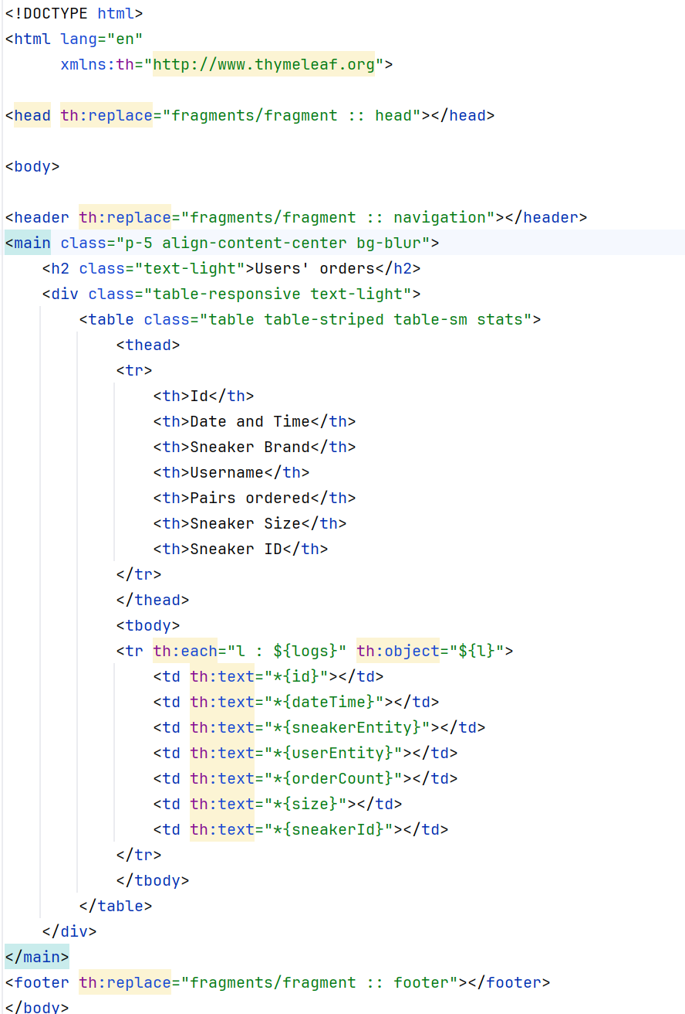

**Illustration 29: The Stats.html Thymeleaf Page**

Here we can see that on the Thymeleaf page, each object is listed in the view page. I will show what the page looks like:

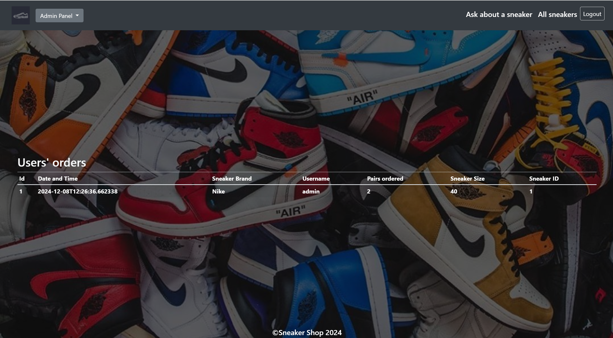

**Illustration 30: The View of the Statistics**

The logic is implemented through aspect-oriented programming. When an order is created and the “Order” button is clicked, the application always waits for it, and each time an order is created, a new log is created.

Aspect-Oriented Programming (AOP) is a programming paradigm developed to more effectively address cross-cutting concerns in software applications. These concerns, such as logging, security, error handling or transaction management, often cross the boundaries of individual classes or modules and can lead to confusing and difficult to maintain code when implemented using traditional programming approaches such as object-oriented programming (OOP).

AOP is often used in large software projects in which cross-cutting issues play a significant role. Popular frameworks such as Spring AOP (Java) provide native support for AOP, making it easier for developers to define and apply aspects. Aspect-Oriented Programming is a powerful tool for improving the modularity and maintainability of software. However, it requires careful planning and a good understanding of the underlying concepts in order to be used effectively. Especially in large and complex projects where cross-cutting issues play an important role, AOP can contribute significantly to code quality.

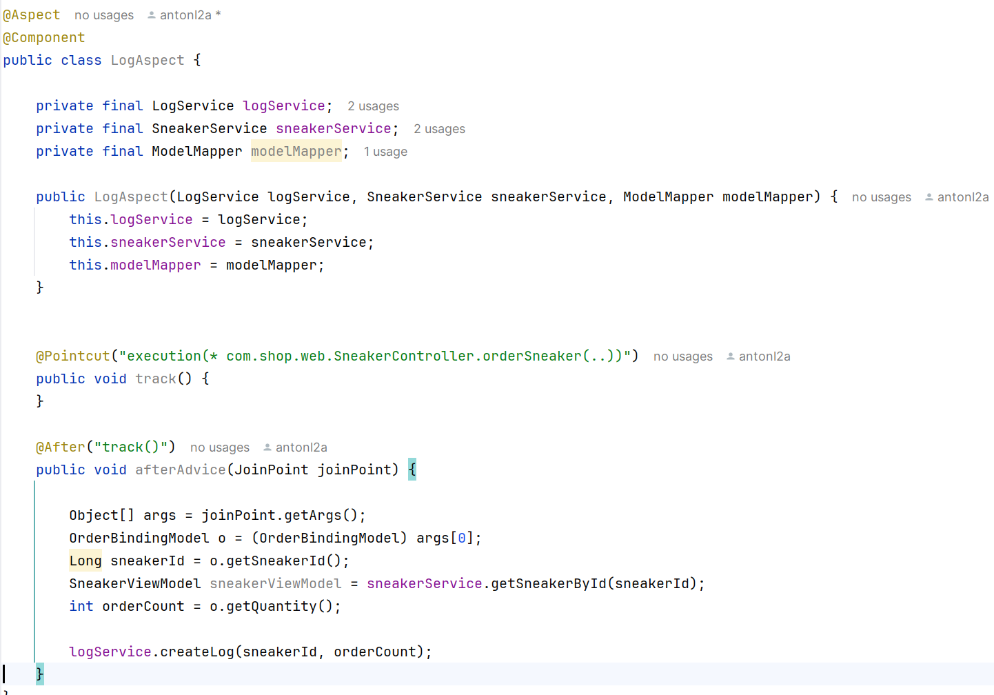

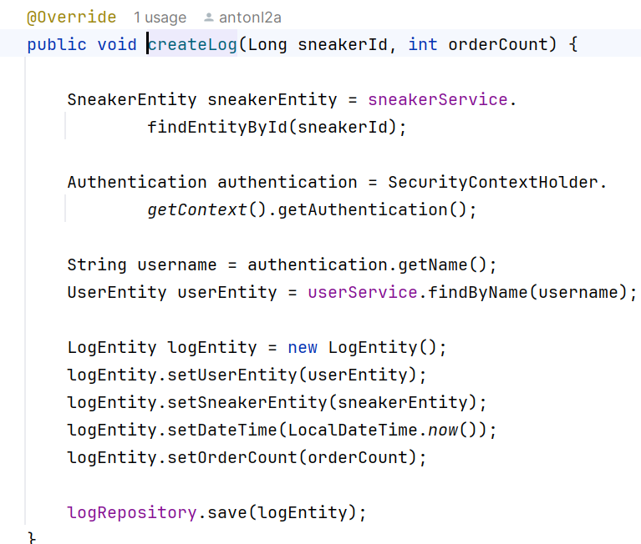

**Illustration 31, 32: The Logic behind AOP**

## 3.7 Implementation of Spring Security

Security is an important part of any application. In our case, we used exactly Spring Security. Spring Security is the most popular alternative for securing Spring applications at the application level. Its main goal is to provide you with a very flexible way to integrate authentication, authorization and protection against common attacks. How I did this can be seen from Figure 32, which gives more information about it.

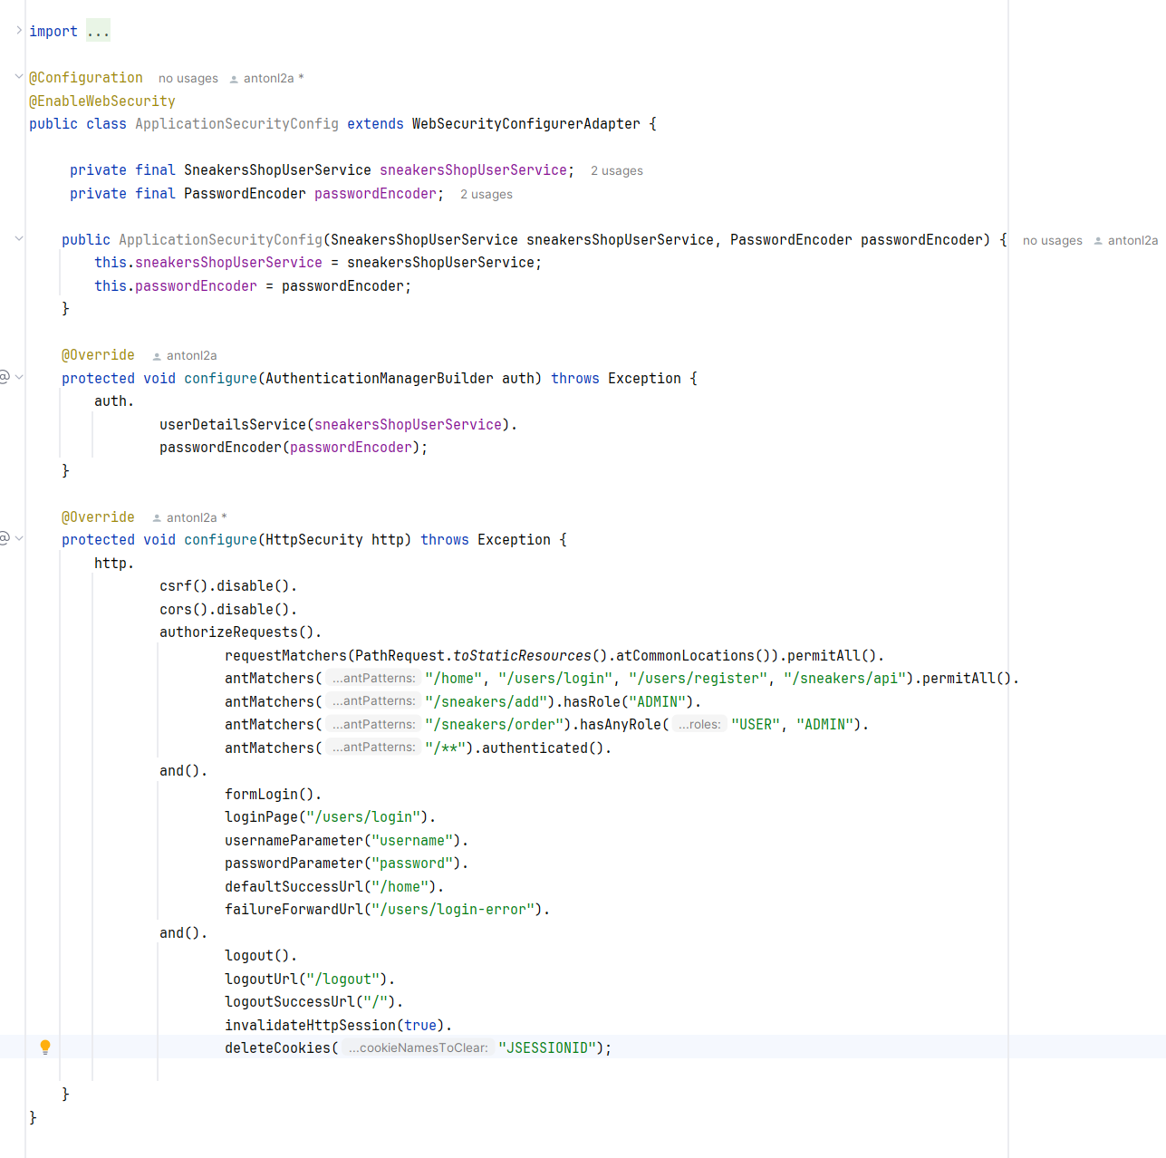

**Illustration 33: Implementation of the Security**

Important aspects of the security part of our application are the following:

* **Authentication Filter** - The filter that intercepts the requests is known as the authentication filter. After it has intercepted these requests, it attempts to convert the authentication information. As a result, we receive information from the user, such as the user name and password, and store it in the authentication object. Authentication object: This is a basic object that is responsible for validating the user's login information.
* **Authentication Manager** - The authentication manager determines which authentication provider the request should be sent to. In addition, the user does not have to perform numerous steps to validate the credentials as the database can be used for this. Alternatively, they can also use LDAP or one of the system's authentication providers. It is up to the system to find the best authentication provider for the task and deliver the user's request as soon as the authentication provider receives it.
* **Security Context** - The security context is a place where a user can review their data after authenticating and determining whether or not they are a valid user. The user's information is automatically stored in the security context, which then responds to the browser, and attempts to submit the same security information and data flow a second time will fail because the user's credentials have already been confirmed.
* **User Details** - The User Details interface is a tool for determining the user name, password, roles and authorizations of a user. It is also responsible for checking the validity and expiration date of the account. The Spring Security Framework manages a contract, a schema or a draft. In addition, it symbolizes a real person trying to use our application. If the user is satisfied with the default implementation provided by the Spring framework, he can use the User class, which implements the user interface and the implementation of all these abstract methods.

# KAPITEL IV:

## Summary

The aim of this bachelor thesis was to find a solution to the problem of the lack of possibilities to offer different pairs of shoes in Bulgaria and to implement this solution technically. This thesis deals with the technical implementation to show how the technologies work together. The concept and the structure of the san application were documented in detail to show how these technologies work together.

First, the corresponding tables were inserted into a database. The database was created using MySQL, a relational database management system. The tables and their relationships were developed using the JPA interface and the ORM framework Hibernate. The tables were described as entities in Java. The entity-relationship model was also demonstrated and discussed in detail as part of the project.

In the third phase of the project, the implementation of the application's core logic was outlined. The implementation of all main functions of the application was described in detail. Java, JavaScript, Thymeleaf, HTML and CSS implementation examples were shown and explained. The explanations were supplemented by illustrations of the user interface design.

While writing this thesis, I gained a deeper understanding of the Java programming language. By merging the Spring framework with Java, I also discovered how to improve the whole implementation process. For front-end programming and application creation, I also learned a lot about JavaScript, Thymeleaf, HTML5 and CSS3.

## In conclusion, it can be said that the sneaker application fulfills the objective of this bachelor thesis. The WEB application can fulfill the needs of both the customers and the various sellers very well. It is an enormous relief for customers to be able to buy a pair of shoes online in just a few steps. This increases customer satisfaction.

## Literature Sources

1. o.A (o.J.). Spring Security Architecture. Online under: https://docs.spring.io/spring-security/reference/servlet/architecture.html

## List of Abbreviations

API..................................................................................... Application Programming Interface

CSS....................................................................................................... [Cascading Style Sheets](https://en.wikipedia.org/wiki/Cascading_Style_Sheets)

HTML........................................................................................... Hypertext Markup Language

HTTP.............................................................................................. Hypertext Transfer Protocol

JPA............................................................................................................. Java Persistence API

ORM................................................................................................ Object-Relational Mapping

SQL................................................................................................. Structured Query Language